# User Manual for SkinLens

### Version: 1.0

### Date: [12.13.2024]

### Author: Team Biased

## 

## 

## 

## Table of Contents

1. **Introduction**
2. **Key Features**
3. **User Roles**  
   3.1 Guest Patient  
   3.2 Authenticated Patient  
   3.3 Dermatologist
4. **Guest User**  
   4.1 Home Page  
   4.2 Upload Page  
   4.3 Upload Instructions  
   4.4 Select and Image Preview  
   4.5 Upload Image  
   4.6 AI Diagnosis  
   4.7 Retake Test
5. **Authenticated Patient**  
   5.1 Home Page  
   5.2 Account Creation  
   5.3 Login  
   5.4 Upload Page  
   5.5 Select Image and Image Preview  
   5.6 Upload Image  
   5.7 AI Diagnosis, Description, and Treatment Recommendations  
   5.8 View Report  
   5.9 Retake Test  
   5.10 Past Cases  
   5.11 Filter By  
   5.12 Search By  
   5.13 Sort by Date  
   5.14 Dermatologist Consultation  
   5.15 Chat with a Dermatologist  
   5.16 Chat Notifications  
   5.17 Logout
6. **Dermatologist**  
   6.1 Home Page  
   6.2 Account Creation  
   6.3 Login  
   6.4 Search By  
   6.5 Search by Field  
   6.6 Add Comments to Cases  
   6.7 Updated Report  
   6.8 Chat with Patients  
   6.9 Chat Notifications  
   6.10 Logout
7. **Info Page**
8. **Best Practices for Image Uploads**
9. **Troubleshooting**
10. **FAQ**  
    11.1 For Patients  
    11.2 For Dermatologists
11. **Support**

## 

## 

## 

## 1. Introduction

Welcome to **SkinLens**, your reliable tool for skin condition analysis and patient management. SkinLens empowers patients and dermatologists with AI-driven diagnosis, detailed reporting, and real-time communication.

This guide will walk you through the installation, features, and operations to help you make the most of SkinLens.

## 2. Key Features

* AI-powered skin condition diagnosis
* Secure image upload and storage
* Detailed reports with treatment recommendations
* Real-time chat between patients and dermatologists
* Role-specific dashboards for streamlined workflows
* Notifications for case updates
* Patient case history tracking

## 3. User Roles

Guest Patient

Authenticated Patient

Dermatologist

## **4. Guest User**

An unauthenticated user is considered as guest user

### 4.1 Home Page

Click on the website url it directs you to a home page

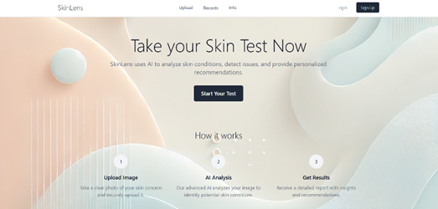

### 4.2 Upload Page

Click on the upload button in the navigation bar or click on start your test at the centre of the screen, it takes you to an upload image page

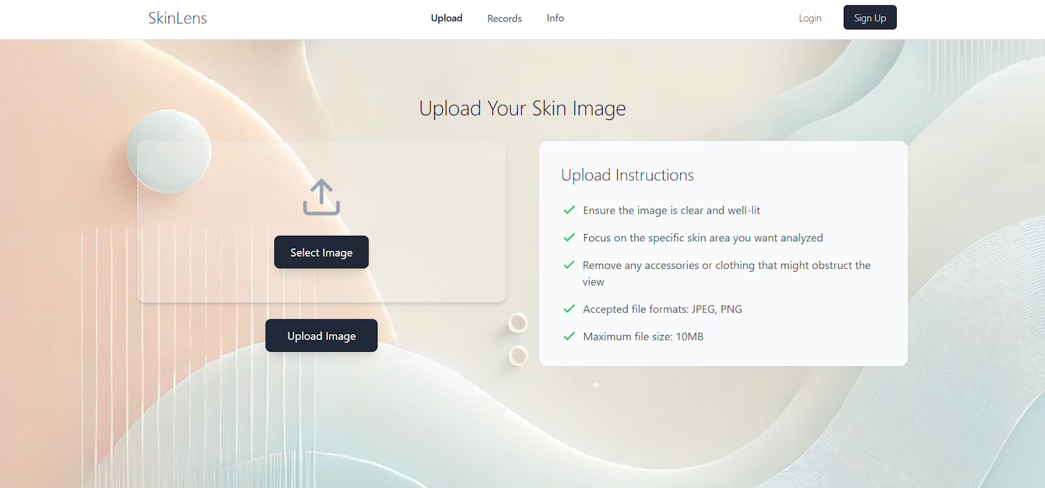

### 4.3 Upload Instructions

On the right side of the upload page, a list of instructions on uploading an image is displayed.

Accepted file formats: JPEG, PNG

### 4.4 Select and Image Preview

Click on the “Select Image” button to select an image file from your local device.

You can also drag and drop an image.

Image preview is visible so that you know it is the right image

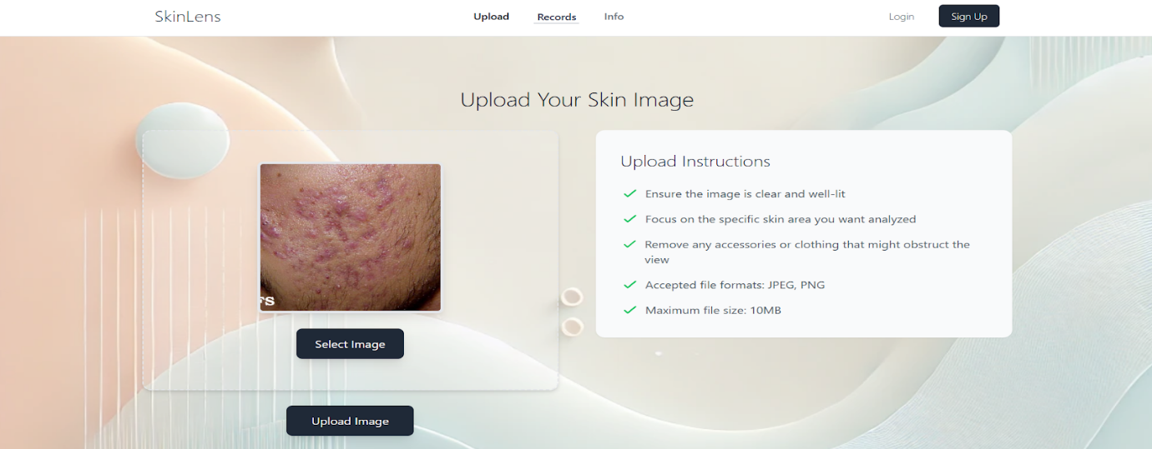

### 4.5 Upload Image

Click on upload image

Image is stored temporarily and gets deleted after 5 minutes maintaining privacy.

Once Image is uploaded, a “Predict Diagnosis” button is displayed

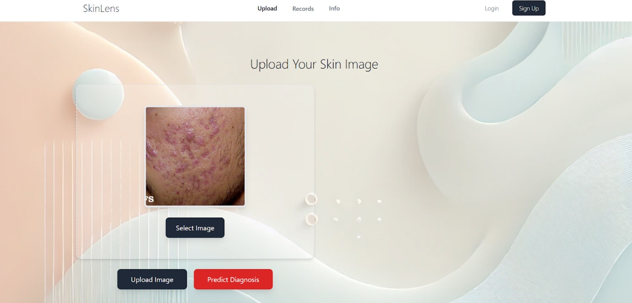

### 4.6 AI Diagnosis

Click on “Predict Diagnosis” button

The Skinlens AI model predicts the diagnosis

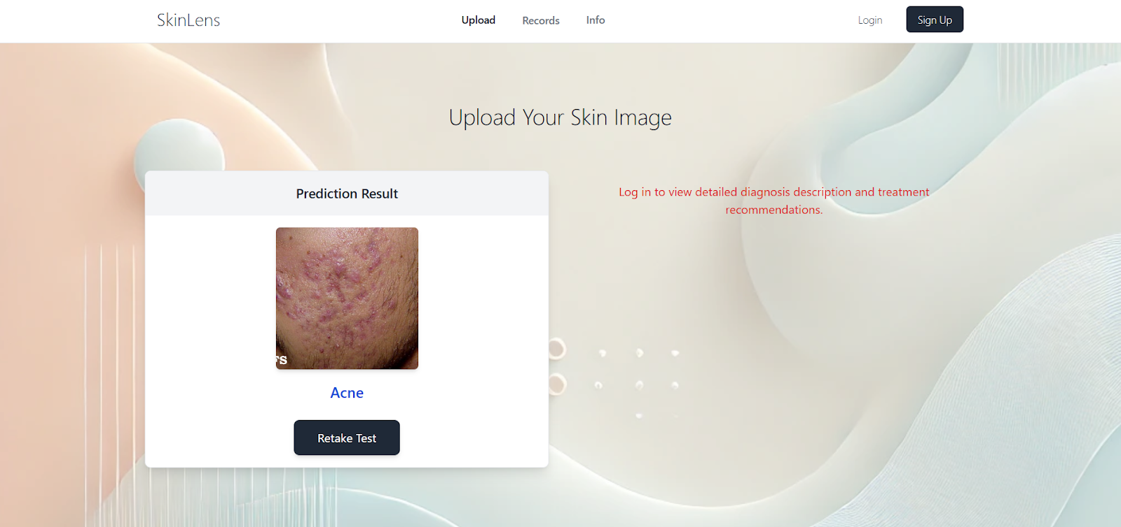

### 4.7 Retake test

Click on “Retake Test” button displayed on the prediction result card

This navigates you to upload image page

You can also click on “SKINLENS” icon in the navigation bar or click on “upload” button

## **5.  Authenticated Patient**

### 5.1 Home Page

Click on the website url it directs you to a home page

### 5.2 Account Creation

Click on the “Sign up” button in the top navigation bar, it redirects you to a sign-up page

Fill in the details, name, valid email id and a strong password

In the role section, Select Patient from the dropdown Menu

Click on “Sign Up” button after filling in the details

It redirects to your own dashboard i.e., a patient dashboard.

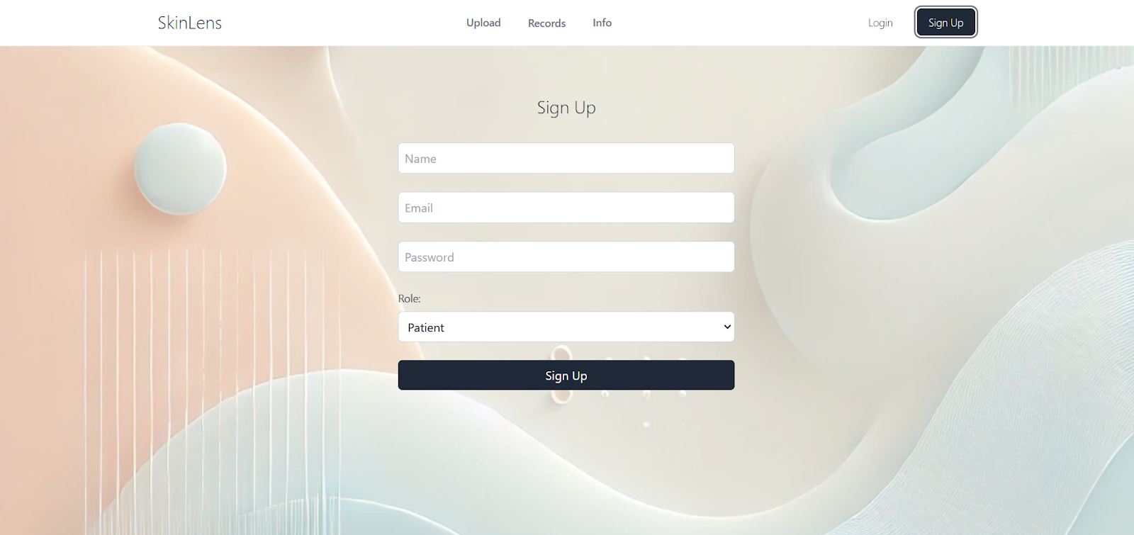

### 5.3 Login

Click on the “Login” button in the navigation bar, it takes you to a login page

Enter valid credentials and login

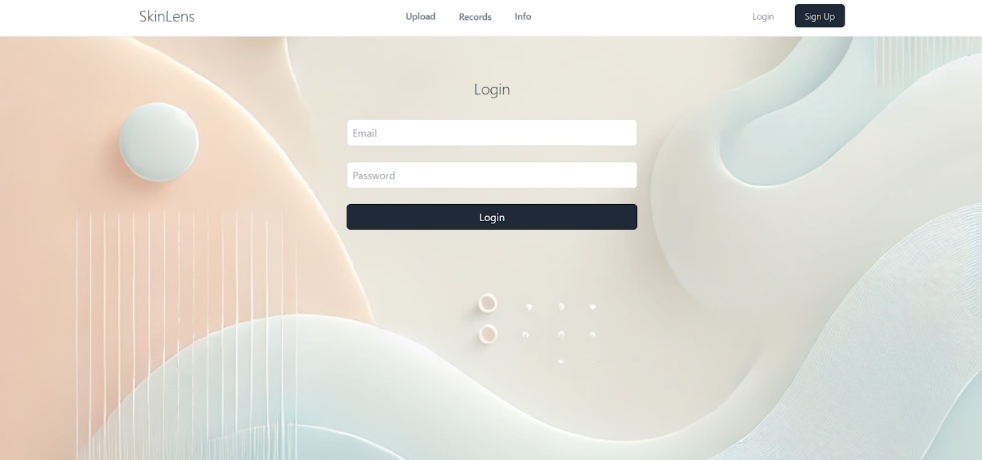

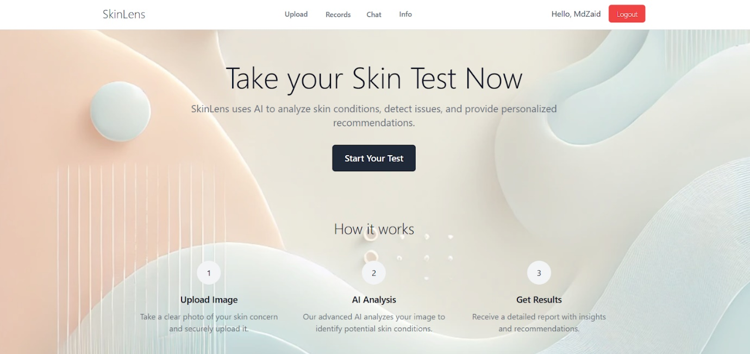

### 5.4 Upload Page

Click on the upload button in the navigation bar or click on start your test at the centre of the screen, it takes you to an upload image page

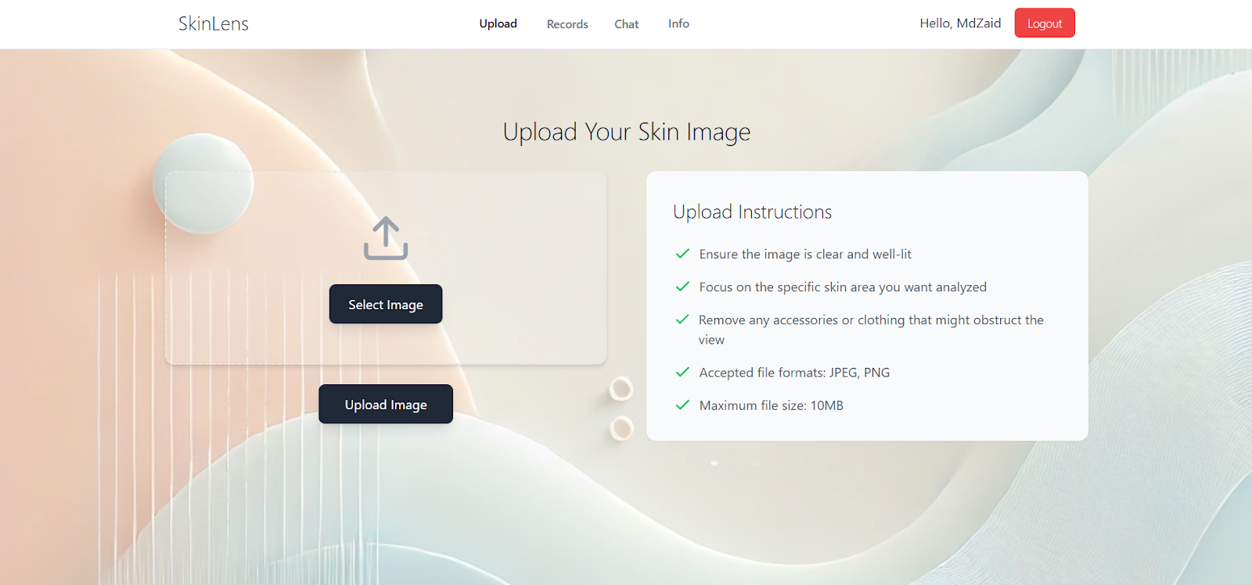

### 5.5 Select Image and Image Preview

Click on the “Select Image” button to select an image file from your local device.

You can also drag and drop an image.

Image preview is visible so that you know it is the right image

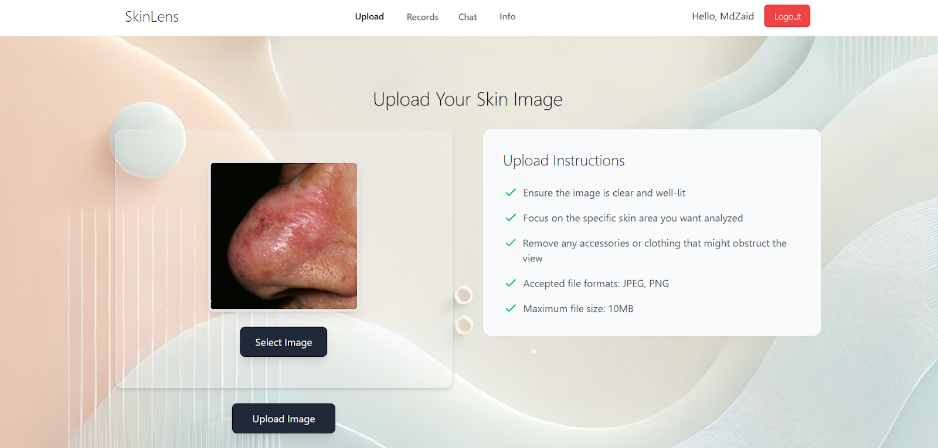

### 5.6 Upload Image

Click on upload image

Image is stored securely and a confirmation message is displayed

Once an Image is uploaded, a “Predict Diagnosis” button is displayed.

A case is also generated associated with this image with status “Open”

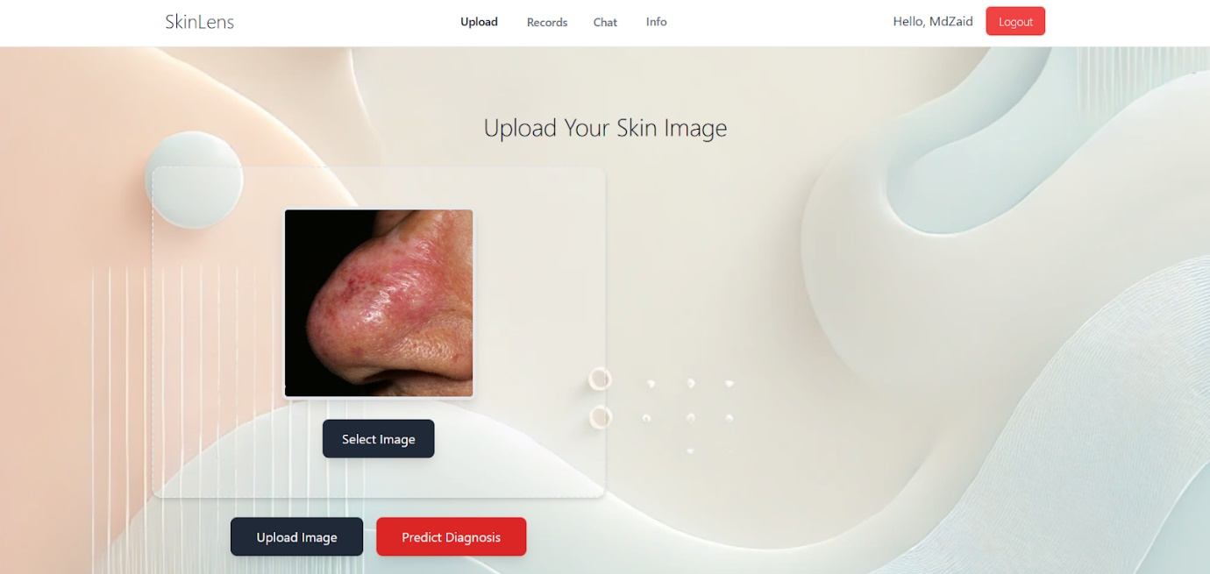

### 5.7 AI Diagnosis, Description and Treatment Recommendations

Click on “Predict Diagnosis” button

The Skinlens AI model predicts the diagnosis

Description and Treatment Recommendations are also visible on the right.

The status of case changes to “Pending Review”

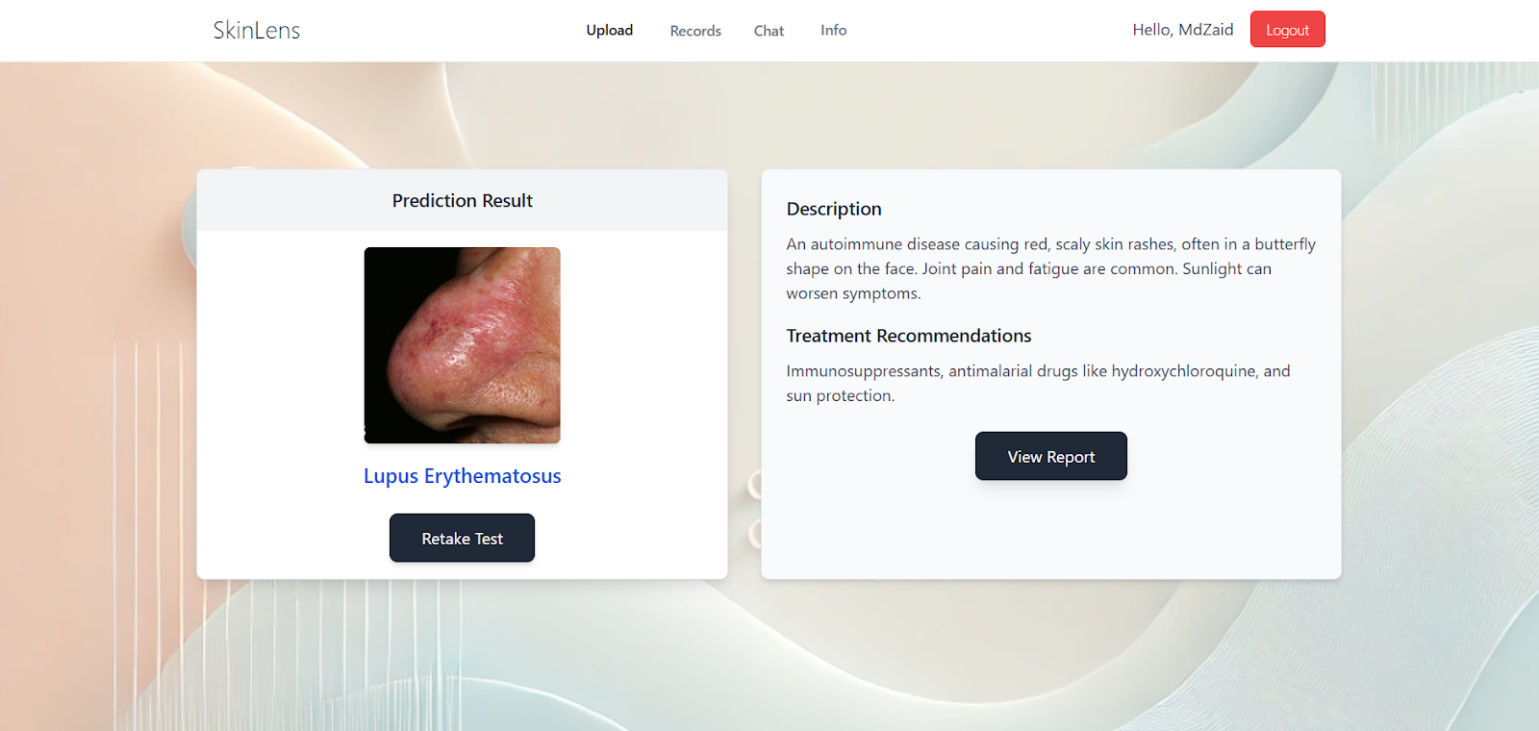

### 5.8 View Report

Click on the “View Report” button below the Treatment Recommendations

A comprehensive report with necessary details is displayed as a modal.

Click on X on the right corner of the modal to close the report.

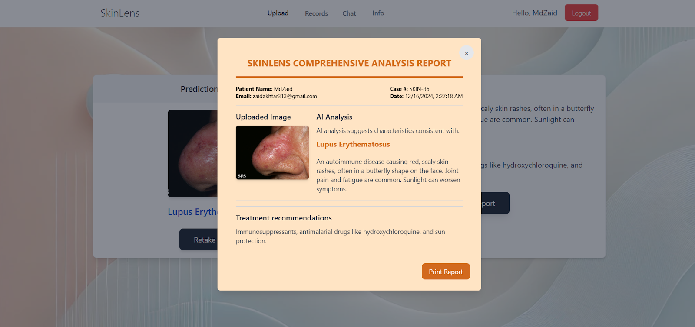

### 5.9 Retake test

Click on “Retake Test” button displayed on the prediction result card

This navigates you to upload image page

You can also click on “SKINLENS” icon in the navigation bar or click on “upload” button

### 5.10 Past cases

Click on “Records” in the navigation bar to navigate to your dashboard.

A tabular list of all the cases is displayed with case id, date, diagnosis, status and actions

On the bottom there is a pagination feature, click on “Previous” or “Next” to move among the pages.

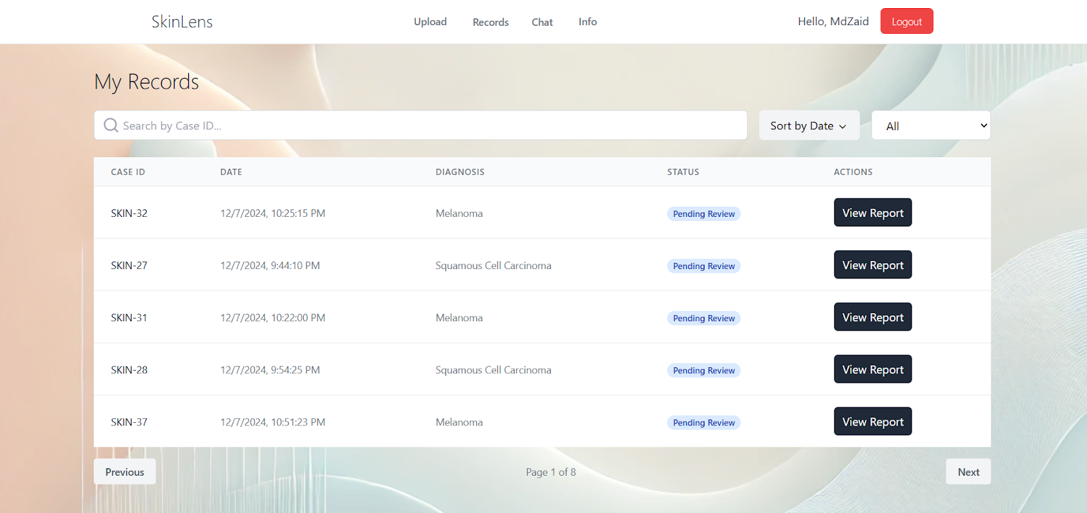

### 5.11 Filter By

Click on “All” on the right most of the search bar

Select any option from the dropdown menu to filter the cases.

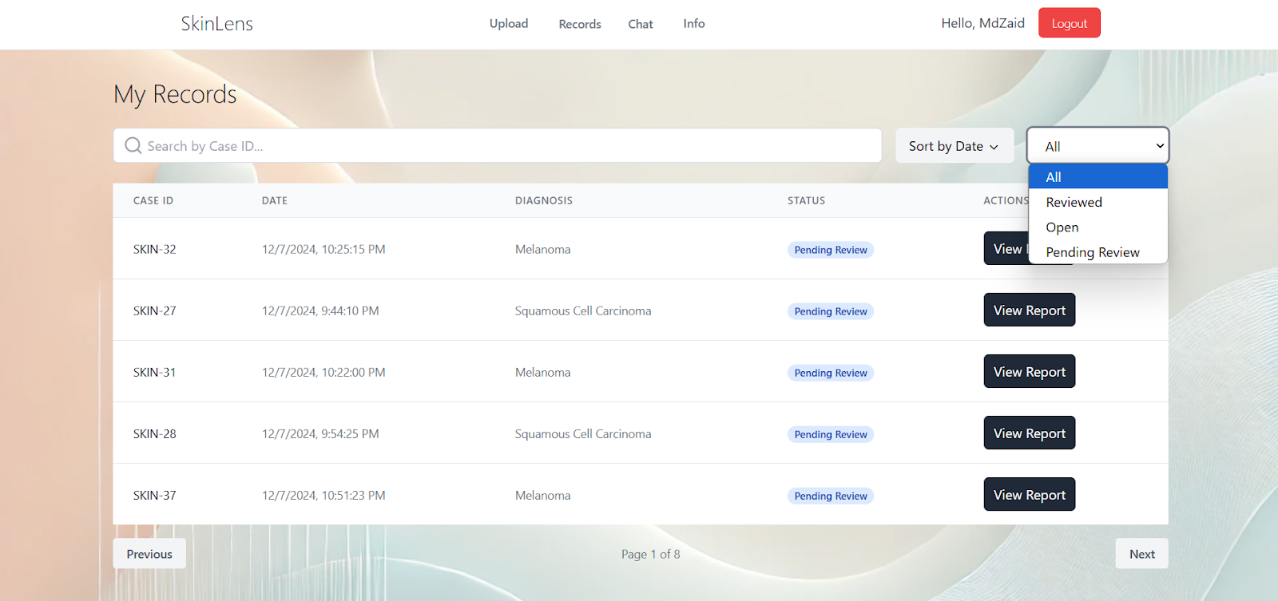

### 5.12 Search By

In the search bar type in the case id to search a particular case

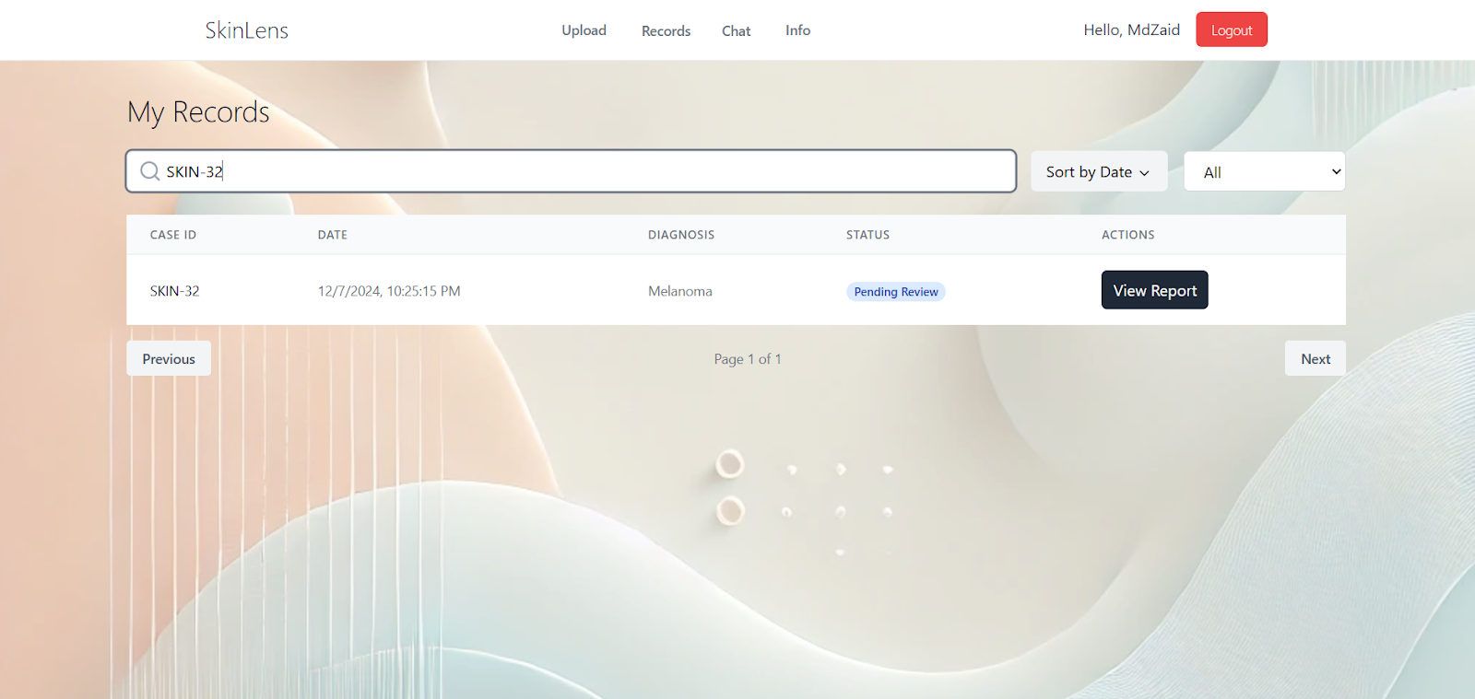

### 5.13 Sort by Date

Beside the search bar, there is a sort by Date dropdown, click on it to toggle between ascending and descending order by time.

### 5.14 Dermatologist Consultation

Click on the “Chat” button in the top navigation bar, it navigates to a chat list dashboard.

This dashboard has a list of all the available dermatologists on the Skinlens platform

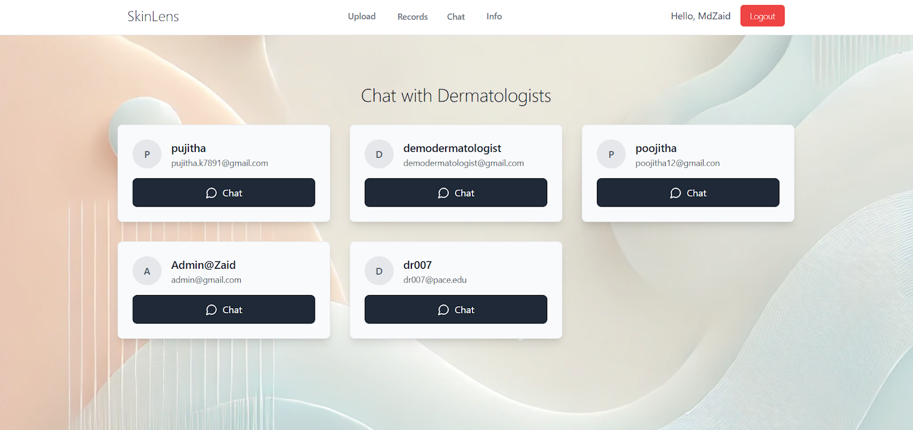

### 5.15 Chat with a particular dermatologist

Click on the Chat button in the specific dermatologist card to initiate a chat.

If there is any previous chat history it is visible.

Click on upload icon to upload image

Click on emoji icon to send an emoji

Below every message there is a timestamp and ticks, single tick represents message sent, double click represents message delivered and blue ticks represents message read.

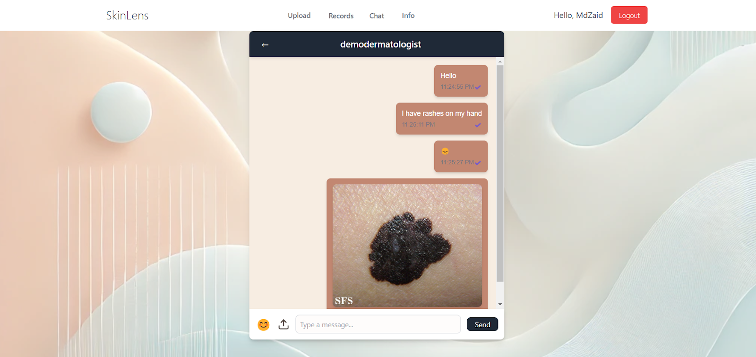

### 5.16 Chat Notifications

If there are any new messages, the number of unread messages is displayed on the chat list dashboard on the dermatologist card that sent you the message.

Red color circle in the second card in first row.

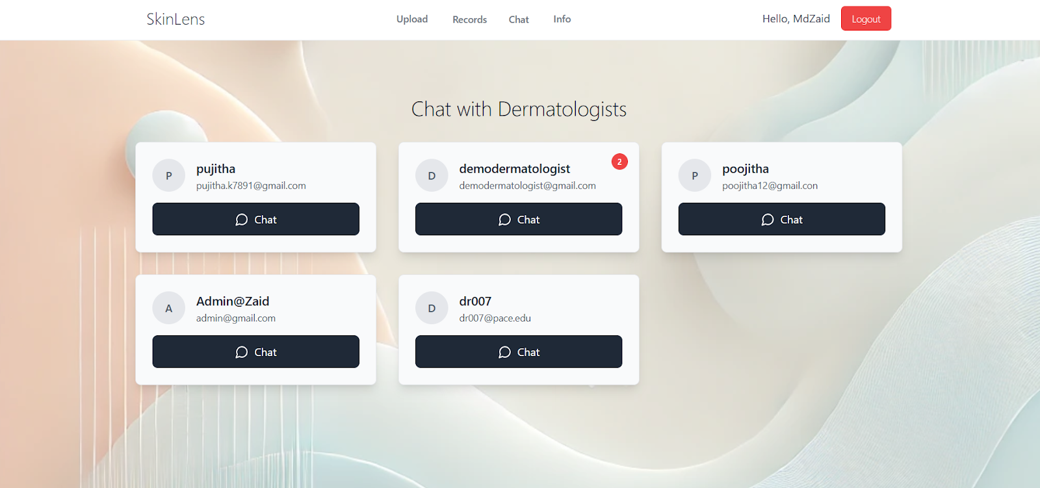

### 5.17 Logout

Click on the logout button in the navigation bar to securely logout.

## **6.  Dermatologist**

### 6.1 Home Page

Click on the website url it directs you to a home page

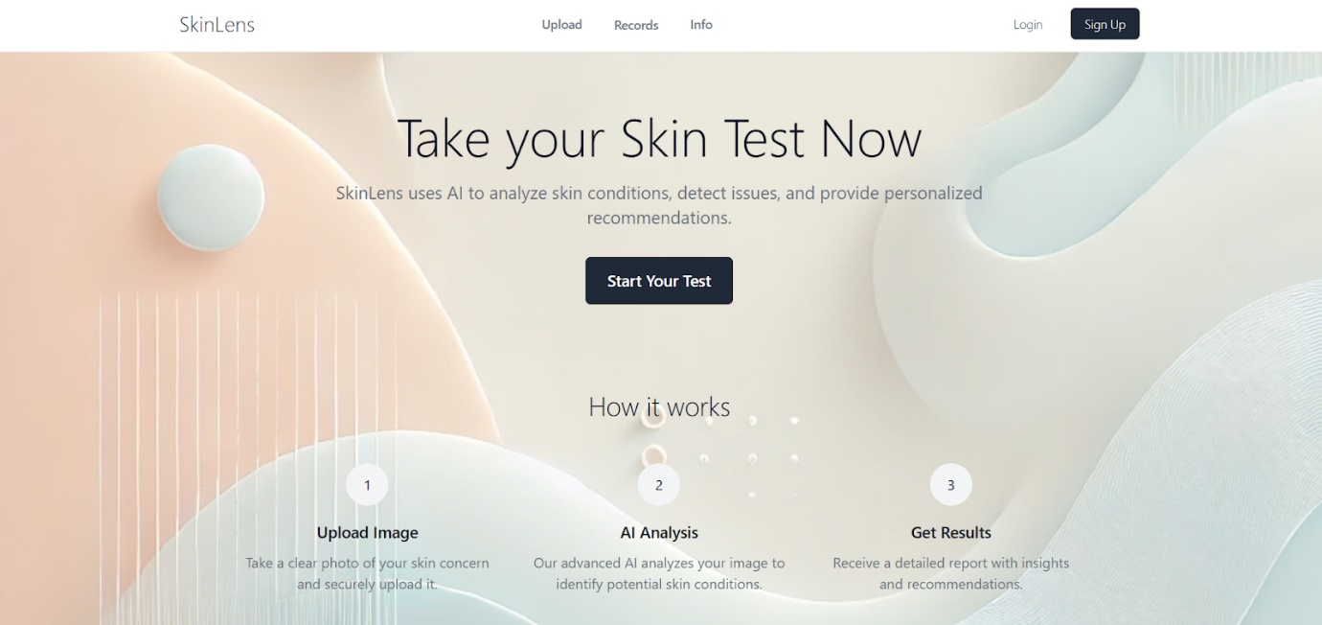

### 6.2 Account Creation

Click on the “Sign up” button in the top navigation bar, it redirects you to a sign-up page

Fill in the details, name, valid email id and a strong password

In the role section, Select Dermatologist from the dropdown Menu

Click on “Sign Up” button after filling in the details

It redirects to the dermatologist dashboard.

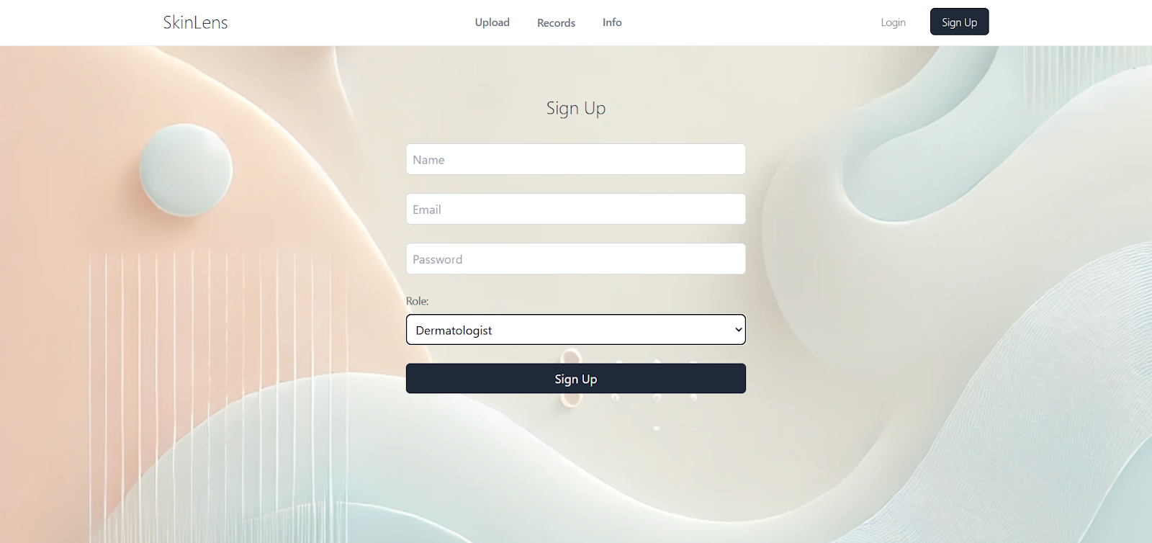

### 6.3 Login

Click on the “Login” button in the navigation bar, it takes you to a login page

Enter valid credentials and login



It redirects you to the dermatologist dashboard page.

List of all the cases generated by all the cases is displayed with details.

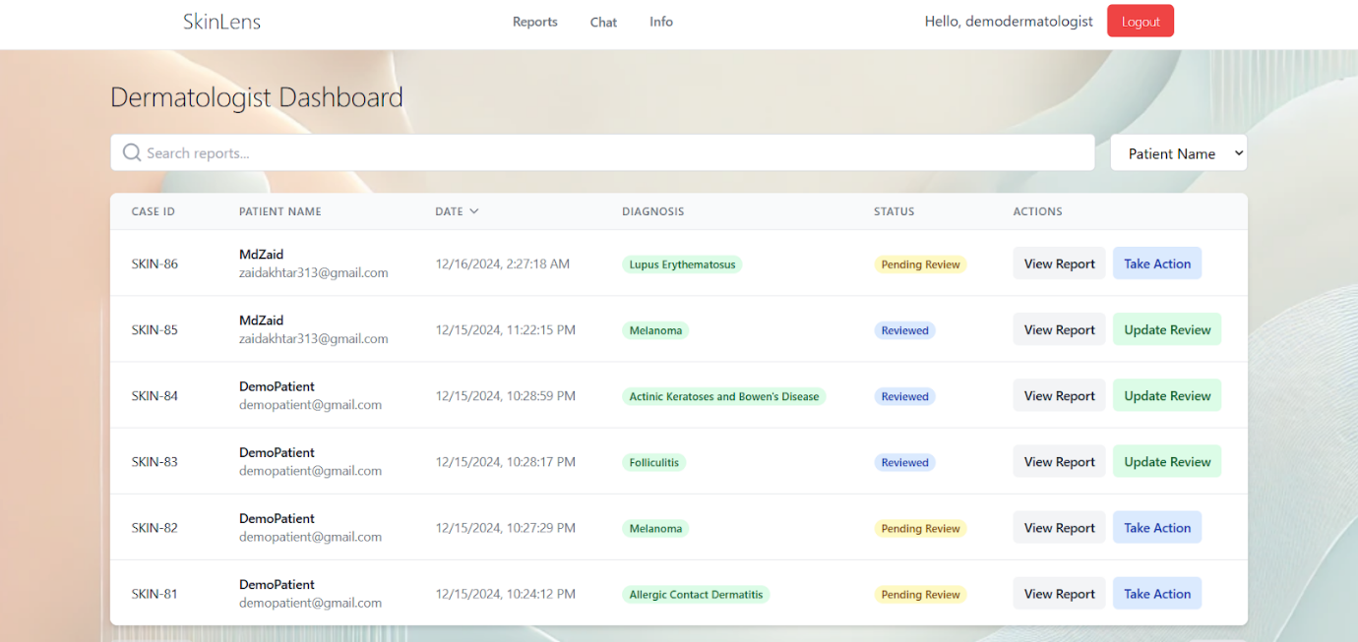

### 6.4 Search By

Click on the dropdown menu on the right to select an option based on which you want to search the cases.

On the bottom there is a pagination feature, click on “Previous” or “Next” to move among the pages.

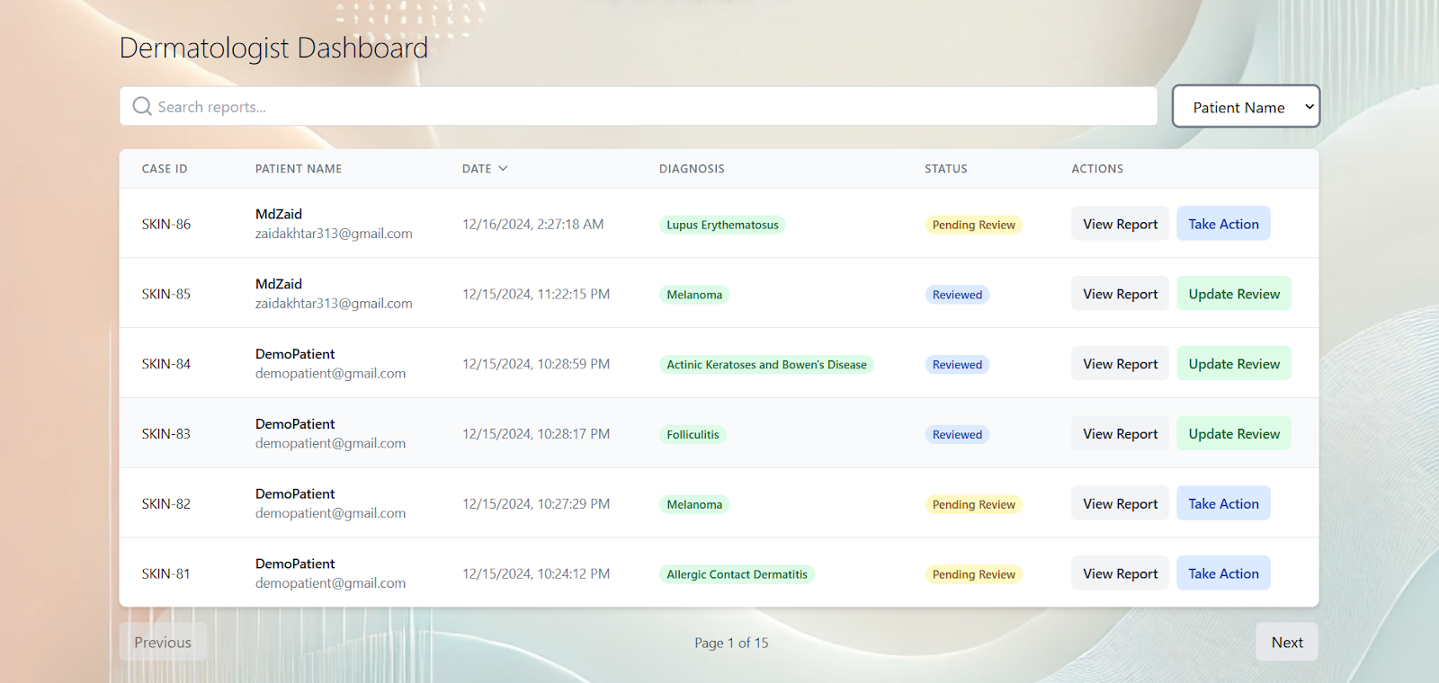

### 6.5 Search By

In the search bar type in the feature you selected in the dropdown menu to search cases based on that particular field.

### 6.6 Dermatologist comment

Click on the “Take Action” button beside a particular case to add a comment to it.

Write a comment and click on “Submit Review”

The status of the case changes to “reviewed”.

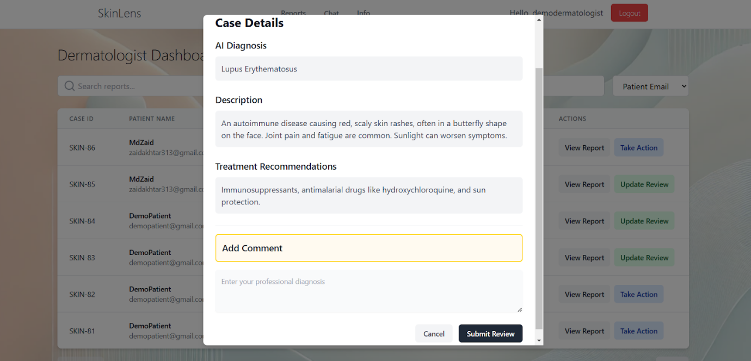

### 6.7 Updated Report

Once the status of the report is changed, the dermatologist comment is added to the report along with necessary details.

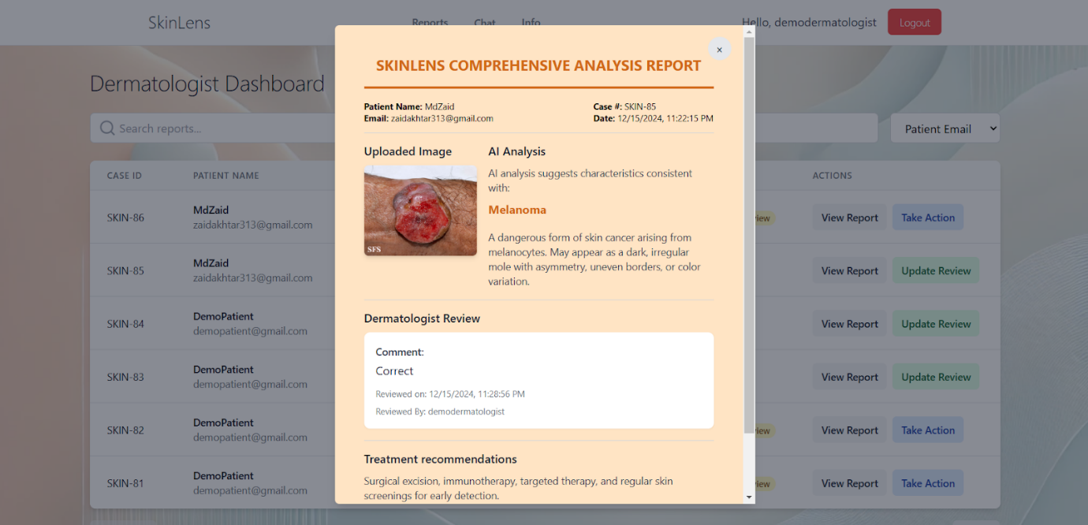

### 6.8 Chat with a patient

Click on “Chat” button in the navigation bar to navigate to chat list page

A list of all the patients is displayed.

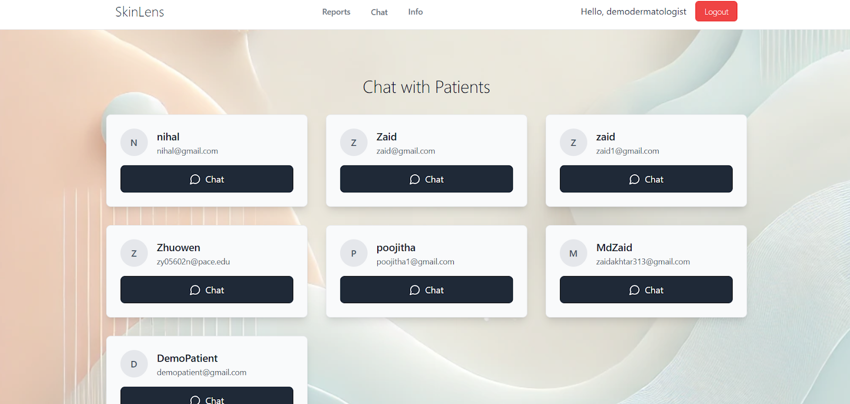

### 6.9 Chat with a particular dermatologist

Same as 5.15

### 6.10 Chat Notifications

Same as 5.16

### 6.11 Logout

Click on the logout button in the navigation bar to securely logout.

## **7. Info Page**

For any of the users click on Info in the navigation bar to navigate to the info page.

This page shows the diseases predicted by skinlens platform.

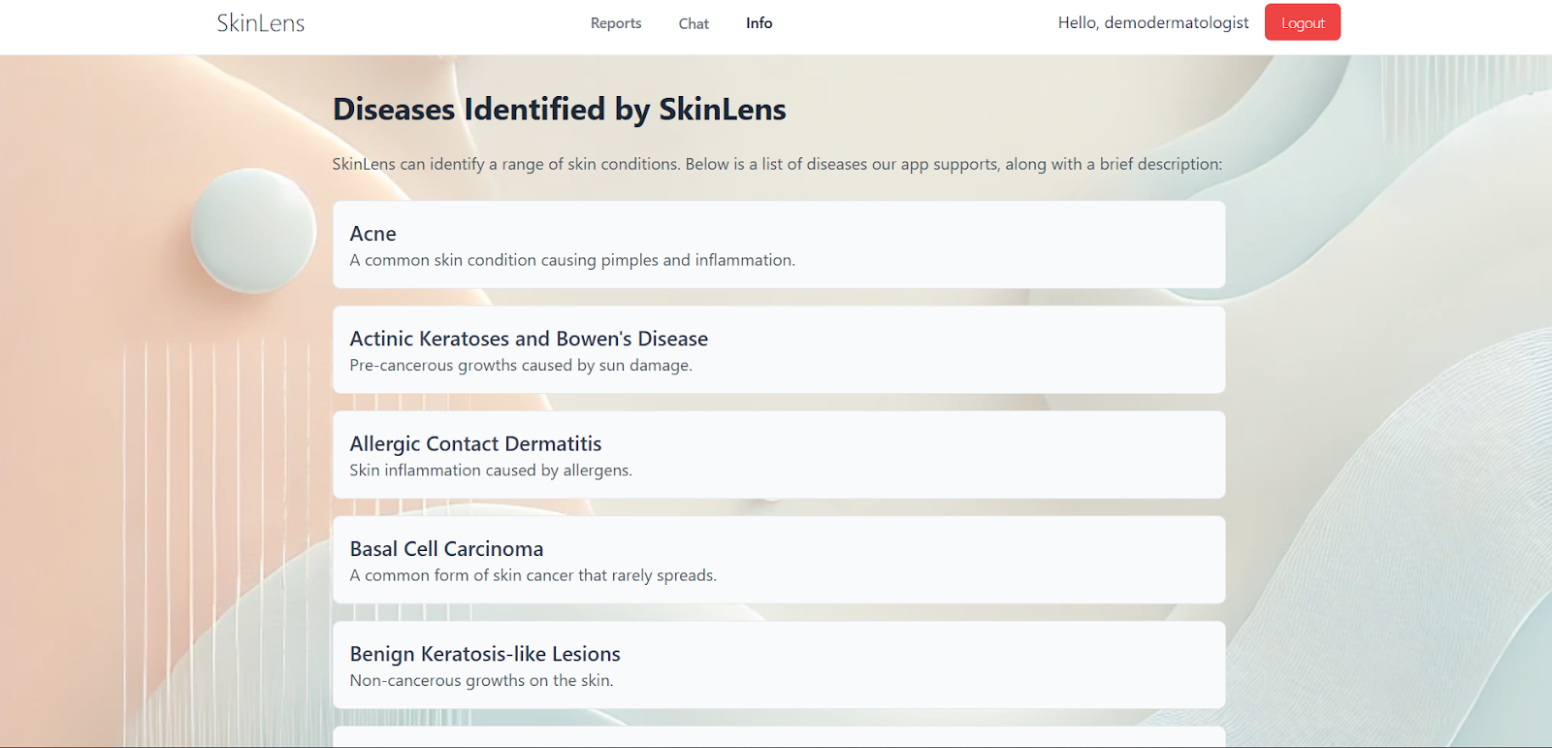

## **8. Best Practices for Image Uploads**

**· Lighting**: Use natural light to capture clear images.

**· Focus**: Ensure the affected area is sharp and in focus.

**· Background**: Use a neutral background to avoid distractions.

**· Multiple Angles**: Upload images from different angles for a comprehensive diagnosis.

## **10. Troubleshooting**

**Issue**: Unable to upload images.  
**Solution**: Ensure the image is in a supported format (JPEG, PNG). Clear browser cache and try again.

**Issue**: Diagnosis taking too long.  
**Solution**: Check your internet connection and refresh the page.

## **11. FAQ**

### Patients

1. Can SkinLens replace a dermatologist?  
SkinLens provides initial diagnosis and recommendations but does not replace professional consultations.

2. Is my data secure?  
Yes, all images and personal data are encrypted and stored securely.

**Dermatologists**

3. Can I track patient progress over time?  
Yes, SkinLens maintains patient records and tracks updates for long-term care.

4. What skin conditions are supported?  
SkinLens currently diagnoses over 20 conditions, including eczema, acne, and psoriasis.

## **11. Support**

For further assistance, contact our support team:

**· Email**: skinlensbiased@gmail.com